Hangman Game Project

- Introduction:

The Hangman Game Project is a simple yet engaging word-guessing game developed in C++. It provides players with the opportunity to guess a word from a specific category within a limited number of attempts. The game challenges the user’s vocabulary and logical thinking skills while providing an interactive gaming experience.

- Project Details:

- Goals and Objectives

Goals:
To create a user-friendly game that challenges the player's word-guessing abilities.
To integrate a learning element by introducing diverse categories and topics.

Objectives:
Provide a structured and interactive gaming experience.
Enhance the player’s engagement through progressive levels and stages.
Utilize fundamental programming concepts to create a fully functional and robust game.

- Technical Details

The Hangman game operates by selecting a random word from a pre-defined list based on the player's current level and category. The player guesses letters within a limited number of attempts.
Key features include:
Dynamic Word Selection: Randomized word generation from categories such as Fruits, Cars, Technology, etc.
Progression System: Three stages per level with increasing difficulty.
Attempt Tracking: Visual representation of attempts left using a hangman graphic.
Input Validation: Ensures valid guesses and prevents repeated letters.

- Architecture Overview:

The project uses a structured approach, with the main program logic divided into distinct modules for better readability and functionality.
Modules:
Word selection based on category and level. Game interface display (category, stage, attempts left, guessed letters).Logic for validating player input and updating the game state. A hangman graphic that dynamically updates based on remaining attempts.

Flow:
1. The program generates a random word.
2. Player guesses letters, with feedback provided for each guess.
3. Game progresses to the next stage or ends based on the outcome.
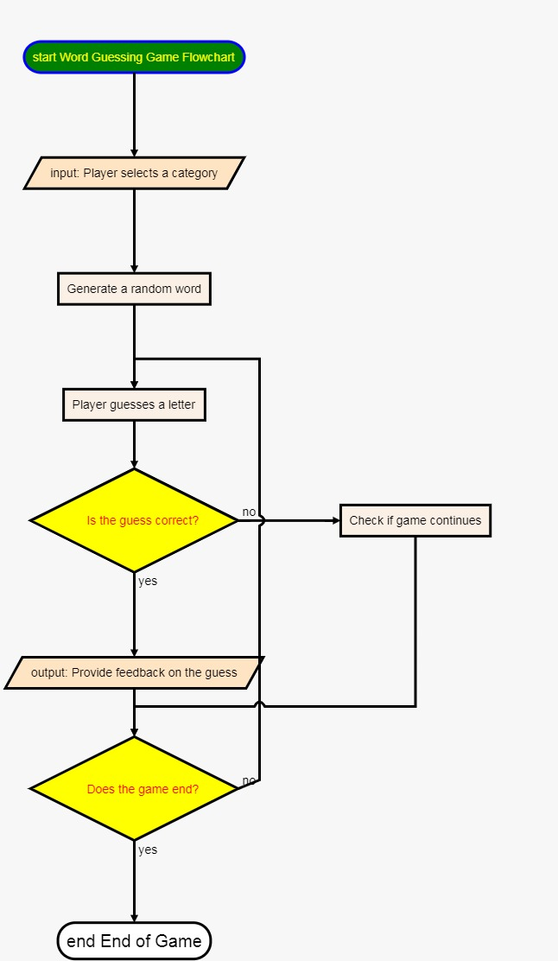

- Tools and Technologies

Programming Language: C++

Development Tools:
IDEs like Visual Studio or Code::Blocks for writing and compiling the code.
Standard C++ libraries for handling input, output, and randomization.
Operating System: Cross-platform compatibility for Windows, macOS, and Linux.

- Conclusion:

The Hangman Game Project successfully demonstrates the application of core programming principles in creating an interactive and enjoyable game. With its structured design, diverse categories, and progressive difficulty, the game engages users while promoting logical thinking and vocabulary improvement. This project is an excellent example of how fundamental programming concepts can be used to create real-world applications.

